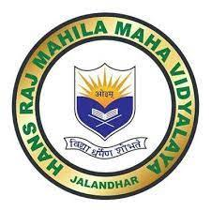

7.1.8: INSTITUTIONAL EFFORTS IN

PROVIDING INCLUSIVE ENVIRONMENT
Any Other Relevant Information

All activities of college are shared on social media.

- HMV FACEBOOK PAGE: https://www.facebook.com/hmvofficial/

- HMV NEWS BLOGSPOT: http://hmvnews.blogspot.com/

Various clubs and societies are working for promoting inclusive environment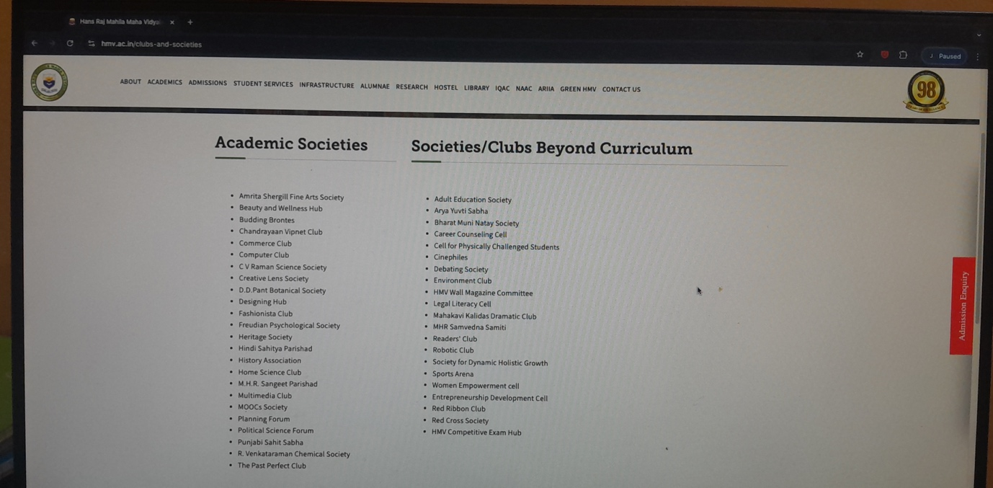

https://www.hmv.ac.in/clubs-and-societies

REPORT OF ARYA YUVTI SABHA:
DOC-20241127-WA0002..pdf

REPORT OF ACTIVITIES OF NCC ARMY WING:
NCC ACTIVITIES 2023-24 (1).docx

REPORT OF ACTIVITIES OF NCC AIR WING:
DOC-20241224-WA0005.docx

Report of Political Science department

Political Science Forum Activities 2023-2024 - Copy.docx

Report of incubation and innovation

Activities of incubation and innovation cell (1).docx

